Communicating Clearly During COVID-19

At a time when parents are fearful about the future and desperately craving information, it’s essential for all communications to be clear and consistent.

Many parents are under great stress—the majority of parents we polled are struggling to balance their work and their child’s learning, with a third of low-income parents rating their level of concern a ten out of ten. Many parents have little margin to sort out messages from the district, their child’s school, and teachers that point in different directions or that ask them to sort through long lists of resources. The need to communicate clearly becomes all the more essential with multiple spokespeople; and polling shows most parents are getting their information from teachers, not from the central office.

That’s why it’s imperative your district lay out key messages that set the tone for all communications. A message triangle is a great tool to do exactly that.

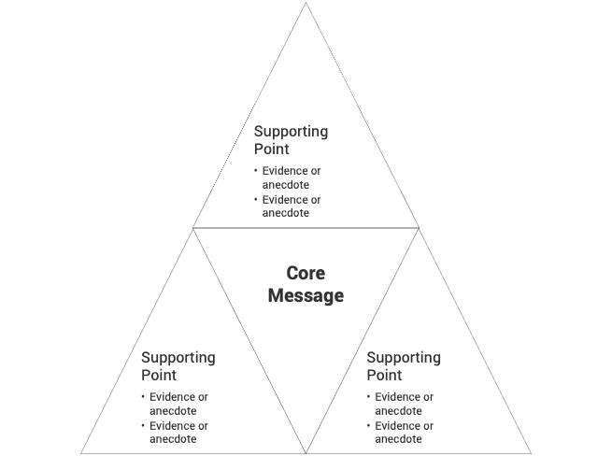

Core Message: First, what’s the headline message you want every family to hear? That goes in the middle of your triangle. A good exercise for identifying it is to imagine your team were handed the keys to the front page of tomorrow’s newspaper. What would you want the headline to read? Ideas for a jumping off point: “Parents: We are Listening.” “The safety and well-being of your kids comes first.”

3-5 Key Messages: Second, surround the triangle with the key messages you want to repeat over and over to support that headline goal. These should be memorable, clear, concise–no education jargon! The message triangle helps limit you to only a few key messages; if you try to include everything, nothing breaks through.

Underneath each of these key messages, you’ll have numbers, stories, and statistics to back it up. Consider stories that center parents or teachers, which are a great way to show you are listening.

A sample triangle is filled out on the next page, with a blank template to download and fill in on the last page. You can think of this triangle like bases on a baseball field: hit all of them in your communications and it’s a home run!

